**Boppudi Vivek(916243)**

**Hands-On: Stage 3 - MVC components in Web page rendering, Data binding concepts in .Net core - Day 63 – Hands on 1**

1. **Create a Razor view to list a few Organizations at Hyderabad and highlight the one that has recently build its largest offshore office at India.**

**HomeController.cs**

**using Microsoft.AspNetCore.Mvc;**

**using Microsoft.Extensions.Logging;**

**using System;**

**using System.Collections.Generic;**

**using System.Diagnostics;**

**using System.Linq;**

**using System.Threading.Tasks;**

**using WebApplication6.Models;**

**namespace WebApplication6.Controllers**

**{**

**public class HomeController : Controller**

**{**

**private readonly ILogger<HomeController> _logger;**

**public HomeController(ILogger<HomeController> logger)**

**{**

**_logger = logger;**

**}**

**public IActionResult Index()**

**{**

**return View();**

**}**

**public IActionResult Privacy()**

**{**

**return View();**

**}**

**public IActionResult ITOrganizations()**

**{**

**List<string> organizationList = new List<string>**

**{**

**"Microsoft www.microsoft.com","CTS www.cognizant.com", "Google", "Amazon","TCS"**

**};**

**return View(organizationList);**

**}**

**[ResponseCache(Duration = 0, Location = ResponseCacheLocation.None, NoStore = true)]**

**public IActionResult Error()**

**{**

**return View(new ErrorViewModel { RequestId = Activity.Current?.Id ?? HttpContext.TraceIdentifier });**

**}**

**}**

**}**

**ITOrganizations.cshtml**

**@\***

**For more information on enabling MVC for empty projects, visit https://go.microsoft.com/fwlink/?LinkID=397860**

**\*@**

**@{**

**}**

**@model List<string>**

**@foreach (var organization in Model)**

**{**

**<div>**

**@if (organization.Equals("Amazon"))**

**{**

**<span><b>@Html.DisplayFor(o => organization)</b></span>**

**}**

**else**

**{**

**<span>@Html.DisplayFor(o => organization)</span>**

**}**

**</div>**

**}**

**_Layout.cshtml**

**@\***

**For more information on enabling MVC for empty projects, visit https://go.microsoft.com/fwlink/?LinkID=397860**

**\*@**

**@{**

**}**

**<!DOCTYPE html>**

**<html lang="en">**

**<head>**

**<meta charset="utf-8" />**

**<meta name="viewport" content="width=device-width, initial-scale=1.0" />**

**<title>@ViewData["Title"] - OrganizationsAtHyderabad</title>**

**<link rel="stylesheet" href="~/lib/bootstrap/dist/css/bootstrap.min.css" />**

**<link rel="stylesheet" href="~/css/site.css" />**

**</head>**

**<body>**

**<header>**

**<nav class="navbar navbar-expand-sm navbar-toggleable-sm navbar-light bg-white border-bottom box-shadow mb-3">**

**<div class="container">**

**<a class="navbar-brand" asp-area="" asp-controller="Home" asp-action="Index">OrganizationsAtHyderabad</a>**

**<button class="navbar-toggler" type="button" data-toggle="collapse" data-target=".navbar-collapse" aria-controls="navbarSupportedContent"**

**aria-expanded="false" aria-label="Toggle navigation">**

**<span class="navbar-toggler-icon"></span>**

**</button>**

**<div class="navbar-collapse collapse d-sm-inline-flex flex-sm-row-reverse">**

**<ul class="navbar-nav flex-grow-1">**

**<li class="nav-item">**

**<a class="nav-link text-dark" asp-area="" asp-controller="Home" asp-action="Index">Home</a>**

**</li>**

**<li class="nav-item">**

**<a class="nav-link text-dark" asp-area="" asp-controller="Home" asp-action="Privacy">Privacy</a>**

**</li>**

**<li class="nav-item">**

**<a class="nav-link text-dark" asp-area="" asp-controller="Home" asp-action="ITOrganizations">ITOrganizations</a>**

**</li>**

**</ul>**

**</div>**

**</div>**

**</nav>**

**</header>**

**<div class="container">**

**<main role="main" class="pb-3">**

**@RenderBody()**

**</main>**

**</div>**

**<footer class="border-top footer text-muted">**

**<div class="container">**

**&copy; 2021 - OrganizationsAtHyderabad - <a asp-area="" asp-controller="Home" asp-action="Privacy">Privacy</a>**

**</div>**

**</footer>**

**<script src="~/lib/jquery/dist/jquery.min.js"></script>**

**<script src="~/lib/bootstrap/dist/js/bootstrap.bundle.min.js"></script>**

**<script src="~/js/site.js" asp-append-version="true"></script>**

**@RenderSection("Scripts", required: false)**

**</body>**

**</html>**

**Output:**

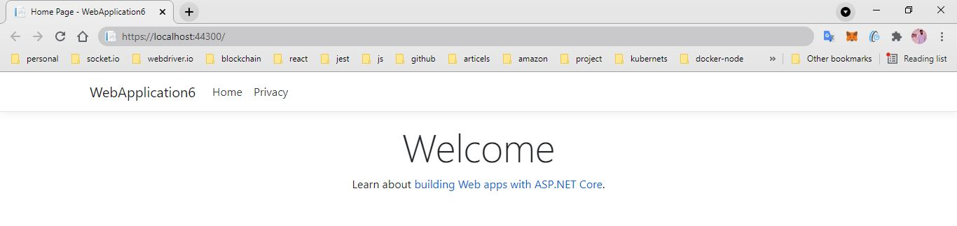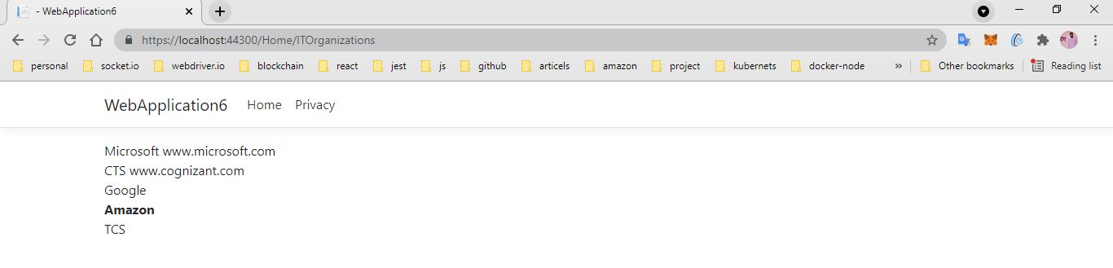

1. **Create a Razor view to list few employee details using Model data binding.**

**Employee.cs**

**using System;**

**using System.Collections.Generic;**

**using System.Linq;**

**using System.Threading.Tasks;**

**namespace WebApplication6.Models**

**{**

**public class Employee**

**{**

**public int Id { get; set; }**

**public string Name { get; set; }**

**public decimal Salary { get; set; }**

**public bool IsPermanent { get; set; }**

**}**

**}**

**HomeController.cs**

**using Microsoft.AspNetCore.Mvc;**

**using Microsoft.Extensions.Logging;**

**using System;**

**using System.Collections.Generic;**

**using System.Diagnostics;**

**using System.Linq;**

**using System.Threading.Tasks;**

**using WebApplication6.Models;**

**namespace WebApplication6.Controllers**

**{**

**public class HomeController : Controller**

**{**

**private readonly ILogger<HomeController> _logger;**

**public HomeController(ILogger<HomeController> logger)**

**{**

**_logger = logger;**

**}**

**public IActionResult Index()**

**{**

**return View();**

**}**

**public IActionResult Privacy()**

**{**

**return View();**

**}**

**public IActionResult GetEmployeeList()**

**{**

**List<Employee> employeeList = new List<Employee>();**

**employeeList.Add(new Employee()**

**{**

**Id = 1,**

**Name = "John",**

**Salary = 10000,**

**IsPermanent = true**

**});**

**employeeList.Add(new Employee()**

**{**

**Id = 2,**

**Name = "Smith",**

**Salary = 5000,**

**IsPermanent = false**

**});**

**employeeList.Add(new Employee()**

**{**

**Id = 3,**

**Name = "Mark",**

**Salary = 5000,**

**IsPermanent = false**

**});**

**employeeList.Add(new Employee()**

**{**

**Id = 4,**

**Name = "Mary",**

**Salary = 5000,**

**IsPermanent = false**

**});**

**return View(employeeList);**

**}**

**[ResponseCache(Duration = 0, Location = ResponseCacheLocation.None, NoStore = true)]**

**public IActionResult Error()**

**{**

**return View(new ErrorViewModel { RequestId = Activity.Current?.Id ?? HttpContext.TraceIdentifier });**

**}**

**}**

**}**

**GetEmployeeList.cshtml**

**@\***

**For more information on enabling MVC for empty projects, visit https://go.microsoft.com/fwlink/?LinkID=397860**

**\*@**

**@{**

**}**

**@model List<WebApplication6.Models.Employee>**

**@{**

**ViewData["Title"] = "GetEmployeeList";**

**<div class="row">**

**<span class="col-md-4">Name</span>**

**<span class="col-md-4">Salary</span>**

**<span class="col-md-4">IsPermanent</span>**

**</div>**

**}**

**@foreach (var employee in Model)**

**{**

**<div class="row">**

**@if (employee.IsPermanent.Equals(true))**

**{**

**<span class="col-md-4"><b>@employee.Name</b></span>**

**<span class="col-md-4"><b>@employee.Salary</b></span>**

**<span class="col-md-4"><b>@employee.IsPermanent</b></span>**

**}**

**else**

**{**

**<span class="col-md-4">@employee.Name</span>**

**<span class="col-md-4">@employee.Salary</span>**

**<span class="col-md-4">@employee.IsPermanent</span>**

**}**

**</div>**

**}**

**_Layout.cshtml**

**@\***

**For more information on enabling MVC for empty projects, visit https://go.microsoft.com/fwlink/?LinkID=397860**

**\*@**

**@{**

**}**

**<!DOCTYPE html>**

**<html lang="en">**

**<head>**

**<meta charset="utf-8" />**

**<meta name="viewport" content="width=device-width, initial-scale=1.0" />**

**<title>@ViewData["Title"] - EmployeeDetails</title>**

**<link rel="stylesheet" href="~/lib/bootstrap/dist/css/bootstrap.min.css" />**

**<link rel="stylesheet" href="~/css/site.css" />**

**</head>**

**<body>**

**<header>**

**<nav class="navbar navbar-expand-sm navbar-toggleable-sm navbar-light bg-white border-bottom box-shadow mb-3">**

**<div class="container">**

**<a class="navbar-brand" asp-area="" asp-controller="Home" asp-action="Index">EmployeeDetails</a>**

**<button class="navbar-toggler" type="button" data-toggle="collapse" data-target=".navbar-collapse" aria-controls="navbarSupportedContent"**

**aria-expanded="false" aria-label="Toggle navigation">**

**<span class="navbar-toggler-icon"></span>**

**</button>**

**<div class="navbar-collapse collapse d-sm-inline-flex flex-sm-row-reverse">**

**<ul class="navbar-nav flex-grow-1">**

**<li class="nav-item">**

**<a class="nav-link text-dark" asp-area="" asp-controller="Home" asp-action="Index">Home</a>**

**</li>**

**<li class="nav-item">**

**<a class="nav-link text-dark" asp-area="" asp-controller="Home" asp-action="Privacy">Privacy</a>**

**</li>**

**<li class="nav-item">**

**<a class="nav-link text-dark" asp-area="" asp-controller="Home" asp-action="GetEmployeeList">GetEmployeeList</a>**

**</li>**

**</ul>**

**</div>**

**</div>**

**</nav>**

**</header>**

**<div class="container">**

**<main role="main" class="pb-3">**

**@RenderBody()**

**</main>**

**</div>**

**<footer class="border-top footer text-muted">**

**<div class="container">**

**&copy; 2021 - EmployeeDetails - <a asp-area="" asp-controller="Home" asp-action="Privacy">Privacy</a>**

**</div>**

**</footer>**

**<script src="~/lib/jquery/dist/jquery.min.js"></script>**

**<script src="~/lib/bootstrap/dist/js/bootstrap.bundle.min.js"></script>**

**<script src="~/js/site.js" asp-append-version="true"></script>**

**@RenderSection("Scripts", required: false)**

**</body>**

**</html>**

**Output:**

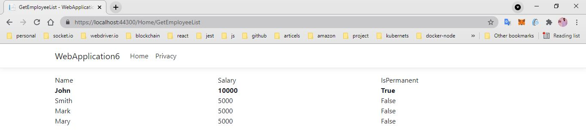

1. **Demonstrate partial view usage.**

**Employee.cs**

**using System;**

**using System.Collections.Generic;**

**using System.Linq;**

**using System.Threading.Tasks;**

**namespace WebApplication6.Models**

**{**

**public class Employee**

**{**

**public int Id { get; set; }**

**public string Name { get; set; }**

**public decimal Salary { get; set; }**

**public bool IsPermanent { get; set; }**

**}**

**}**

**HomeController.cs**

**using Microsoft.AspNetCore.Mvc;**

**using Microsoft.Extensions.Logging;**

**using System;**

**using System.Collections.Generic;**

**using System.Diagnostics;**

**using System.Linq;**

**using System.Threading.Tasks;**

**using WebApplication6.Models;**

**namespace WebApplication6.Controllers**

**{**

**public class HomeController : Controller**

**{**

**private readonly ILogger<HomeController> _logger;**

**public HomeController(ILogger<HomeController> logger)**

**{**

**_logger = logger;**

**}**

**public IActionResult Index()**

**{**

**return View();**

**}**

**public IActionResult Privacy()**

**{**

**return View();**

**}**

**public IActionResult GetEmployeeList()**

**{**

**List<Employee> employeeList = new List<Employee>();**

**employeeList.Add(new Employee()**

**{**

**Id = 1,**

**Name = "John",**

**Salary = 10000,**

**IsPermanent = true**

**});**

**employeeList.Add(new Employee()**

**{**

**Id = 2,**

**Name = "Smith",**

**Salary = 5000,**

**IsPermanent = false**

**});**

**employeeList.Add(new Employee()**

**{**

**Id = 3,**

**Name = "Mark",**

**Salary = 5000,**

**IsPermanent = false**

**});**

**employeeList.Add(new Employee()**

**{**

**Id = 4,**

**Name = "Mary",**

**Salary = 5000,**

**IsPermanent = false**

**});**

**return View(employeeList);**

**}**

**[ResponseCache(Duration = 0, Location = ResponseCacheLocation.None, NoStore = true)]**

**public IActionResult Error()**

**{**

**return View(new ErrorViewModel { RequestId = Activity.Current?.Id ?? HttpContext.TraceIdentifier });**

**}**

**}**

**}**

**GetEmployeeList.cshtml**

**@\***

**For more information on enabling MVC for empty projects, visit https://go.microsoft.com/fwlink/?LinkID=397860**

**\*@**

**@{**

**}**

**<partial name="partialGetEmployeeList" />**

**partialGetEmployeeList.cshtml**

**@\***

**For more information on enabling MVC for empty projects, visit https://go.microsoft.com/fwlink/?LinkID=397860**

**\*@**

**@model List<WebApplication6.Models.Employee>**

**@{**

**ViewData["Title"] = "GetEmployeeList";**

**<div class="row">**

**<span class="col-md-4">Name</span>**

**<span class="col-md-4">Salary</span>**

**<span class="col-md-4">IsPermanent</span>**

**</div>**

**}**

**@foreach (var employee in Model)**

**{**

**<div class="row">**

**@if (employee.IsPermanent.Equals(true))**

**{**

**<span class="col-md-4"><b>@employee.Name</b></span>**

**<span class="col-md-4"><b>@employee.Salary</b></span>**

**<span class="col-md-4"><b>@employee.IsPermanent</b></span>**

**}**

**else**

**{**

**<span class="col-md-4">@employee.Name</span>**

**<span class="col-md-4">@employee.Salary</span>**

**<span class="col-md-4">@employee.IsPermanent</span>**

**}**

**</div>**

**}**

**_Layout.cshtml**

**<!DOCTYPE html>**

**<html lang="en">**

**<head>**

**<meta charset="utf-8" />**

**<meta name="viewport" content="width=device-width, initial-scale=1.0" />**

**<title>@ViewData["Title"] - EmployeeDetails</title>**

**<link rel="stylesheet" href="~/lib/bootstrap/dist/css/bootstrap.min.css" />**

**<link rel="stylesheet" href="~/css/site.css" />**

**</head>**

**<body>**

**<header>**

**<nav class="navbar navbar-expand-sm navbar-toggleable-sm navbar-light bg-white border-bottom box-shadow mb-3">**

**<div class="container">**

**<a class="navbar-brand" asp-area="" asp-controller="Home" asp-action="Index">EmployeeDetails</a>**

**<button class="navbar-toggler" type="button" data-toggle="collapse" data-target=".navbar-collapse" aria-controls="navbarSupportedContent"**

**aria-expanded="false" aria-label="Toggle navigation">**

**<span class="navbar-toggler-icon"></span>**

**</button>**

**<div class="navbar-collapse collapse d-sm-inline-flex flex-sm-row-reverse">**

**<ul class="navbar-nav flex-grow-1">**

**<li class="nav-item">**

**<a class="nav-link text-dark" asp-area="" asp-controller="Home" asp-action="Index">Home</a>**

**</li>**

**<li class="nav-item">**

**<a class="nav-link text-dark" asp-area="" asp-controller="Home" asp-action="Privacy">Privacy</a>**

**</li>**

**<li class="nav-item">**

**<a class="nav-link text-dark" asp-area="" asp-controller="Home" asp-action="GetEmployeeList">GetEmployeeList</a>**

**</li>**

**</ul>**

**</div>**

**</div>**

**</nav>**

**</header>**

**<div class="container">**

**<main role="main" class="pb-3">**

**@RenderBody()**

**</main>**

**</div>**

**<footer class="border-top footer text-muted">**

**<div class="container">**

**&copy; 2021 - EmployeeDetails - <a asp-area="" asp-controller="Home" asp-action="Privacy">Privacy</a>**

**</div>**

**</footer>**

**<script src="~/lib/jquery/dist/jquery.min.js"></script>**

**<script src="~/lib/bootstrap/dist/js/bootstrap.bundle.min.js"></script>**

**<script src="~/js/site.js" asp-append-version="true"></script>**

**@RenderSection("Scripts", required: false)**

**</body>**

**</html>**

**Output:**

